**PRACTICAL 1**

**AIM: Installation and configuration of Instant Contiki OS with Cooja.**

**INSTALLATION:**

Step 1: Download Instant Contiki.

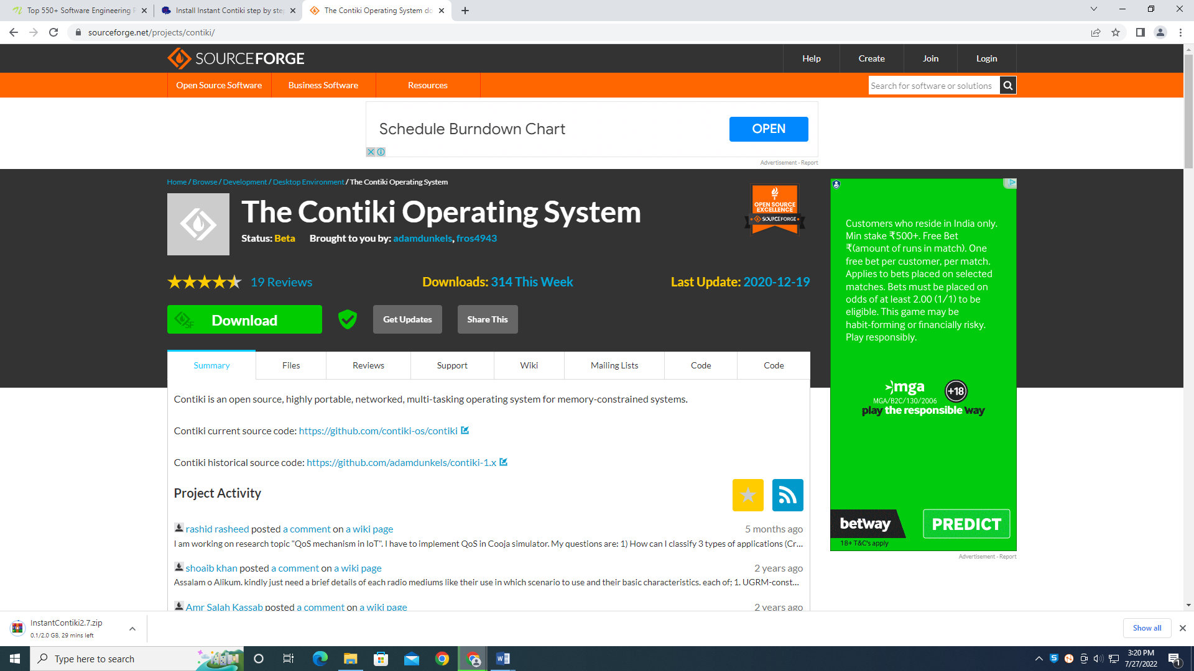

Step 2: Unzip the downloaded file.

Step 3: Start your virtualization software [Vmware](https://my.vmware.com/en/web/vmware/info/slug/desktop_end_user_computing/vmware_workstation_pro/15_0)  and load your Instant Contiki File. In Vmware click Open a Virtual Machine as shown below.

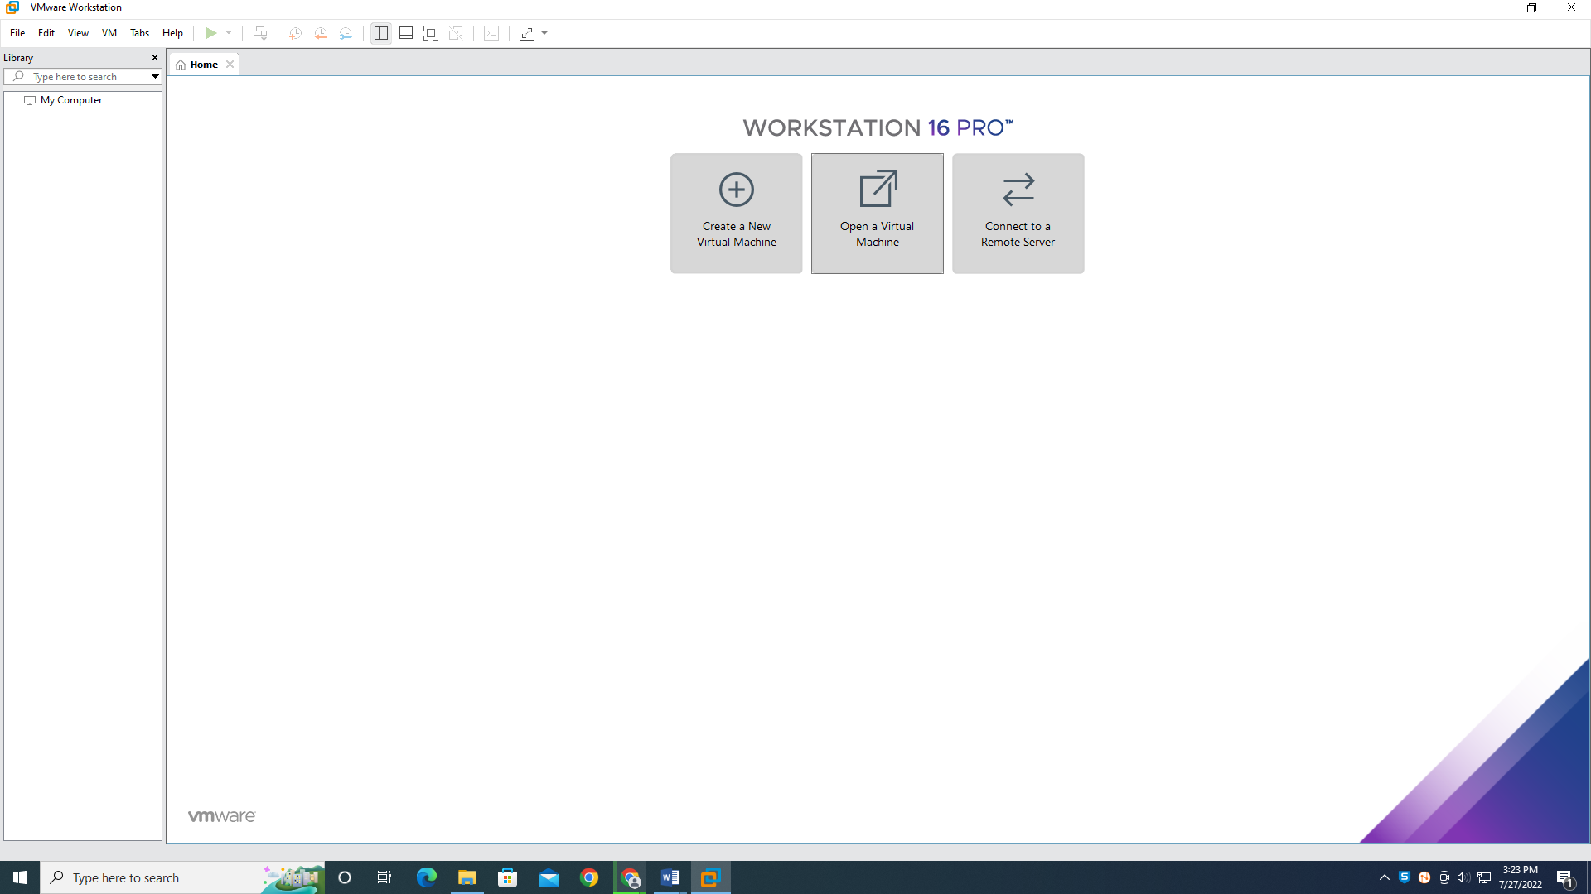

Step 4: Navigate to the extracted folder .vmx file.

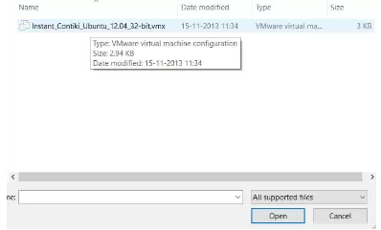

Step 5: Power on the machine.

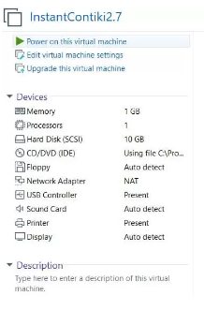

Step 6: Select “I Copied it” option.

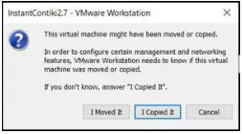

Step 7: Enter the password “user” and login to the Instant Contiki OS.

